Joint Angles Analysis

There are some key factors that we will look at with the averages of the data provided for joint angles and whether or not they were within or outside the +20 to -20 degree threshold set by the Noraxon software. We can also look at the sum of duration within these points to reference that as well. If you have any questions or would like me to change the graphs in any way, I can do that and help answer as to what I found from the data.

# Mean Below Threshold Averages

* 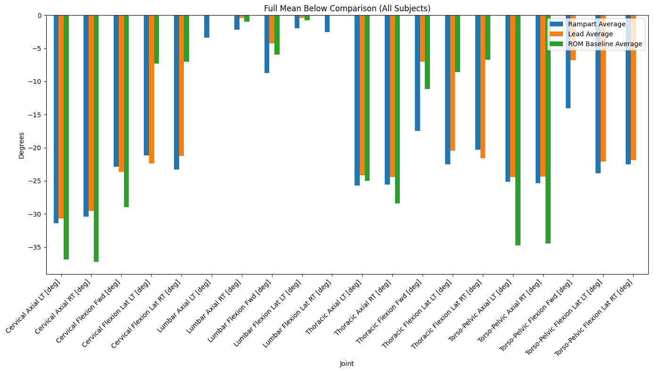
  + Here are the averages that were found from all the values for these instances.
* 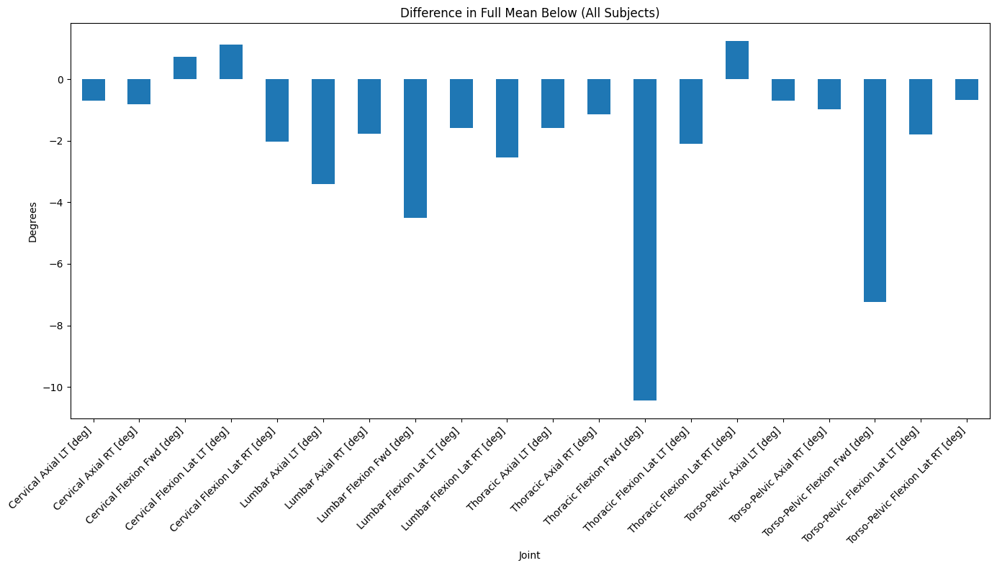
  + The above showcases the difference of rampart - lead for this instance again.
* 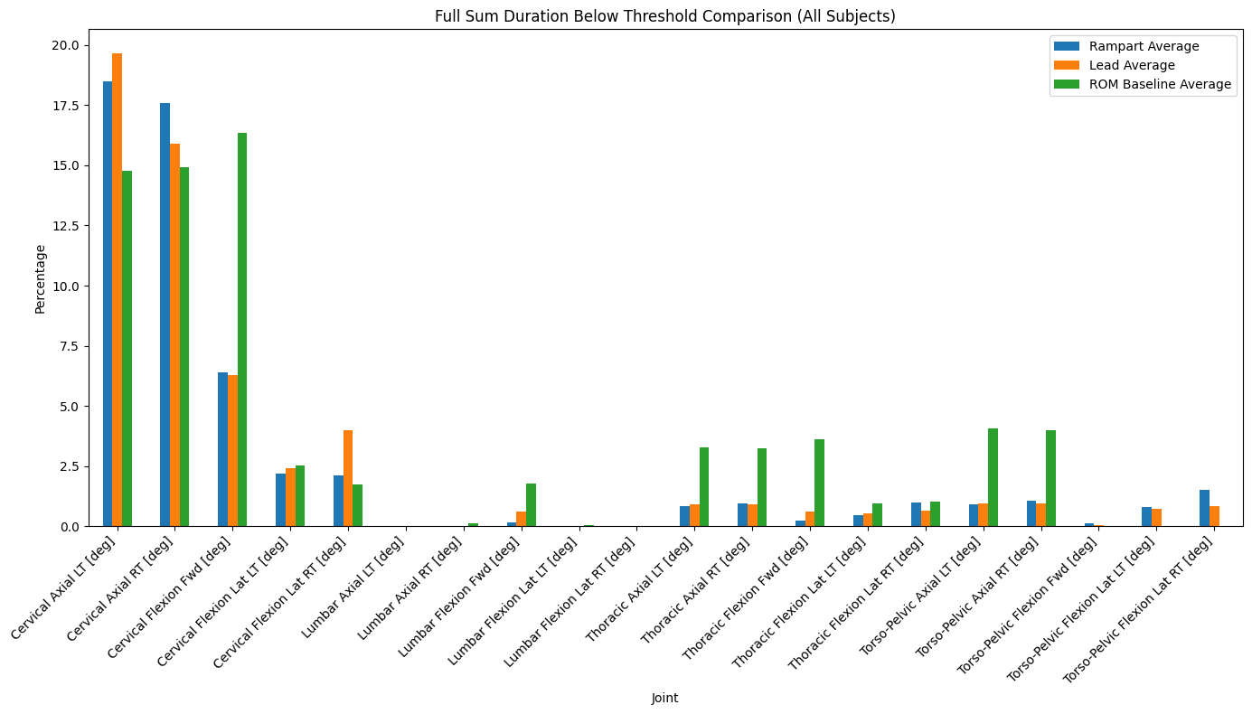
  + Here above are the percentage averages of the sum of duration for each joint below the degree threshold.
* 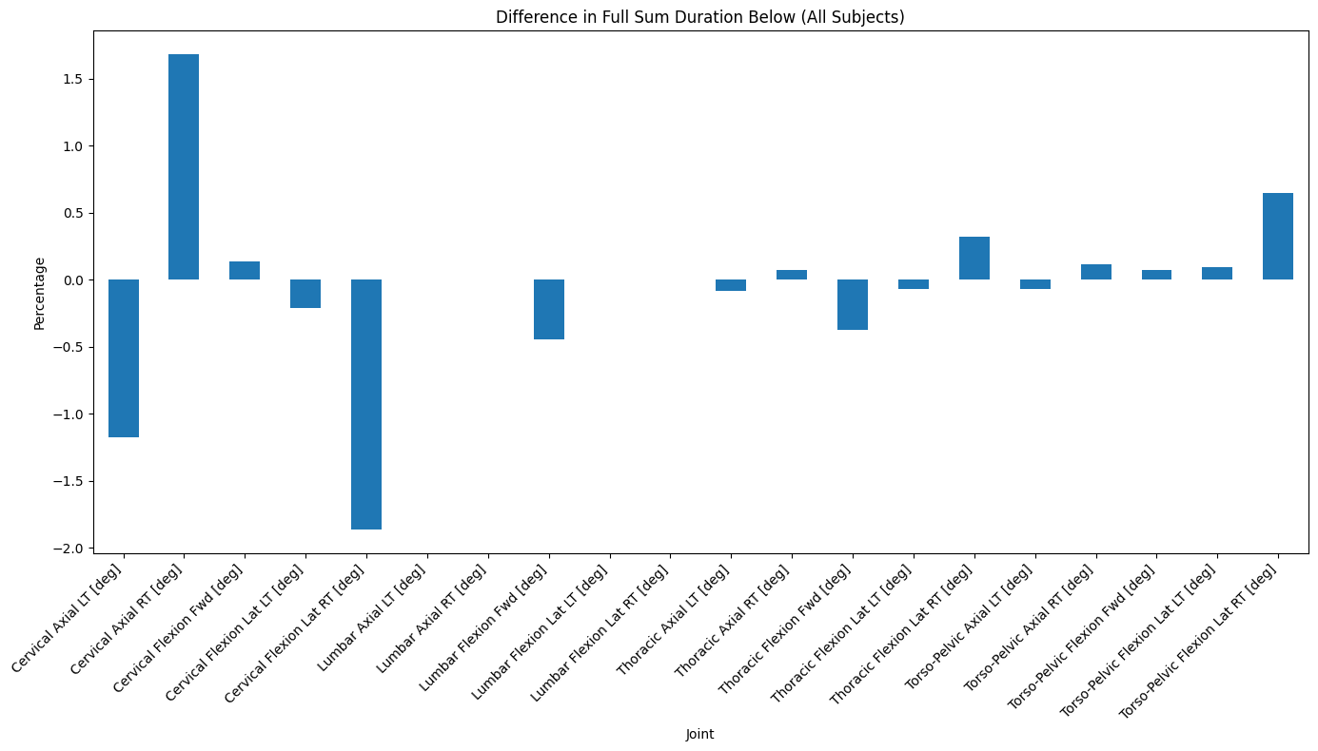
  + This showcases again the difference between the values rampart - lead for the percentages below the threshold.

# Mean Inside Threshold Averages

* 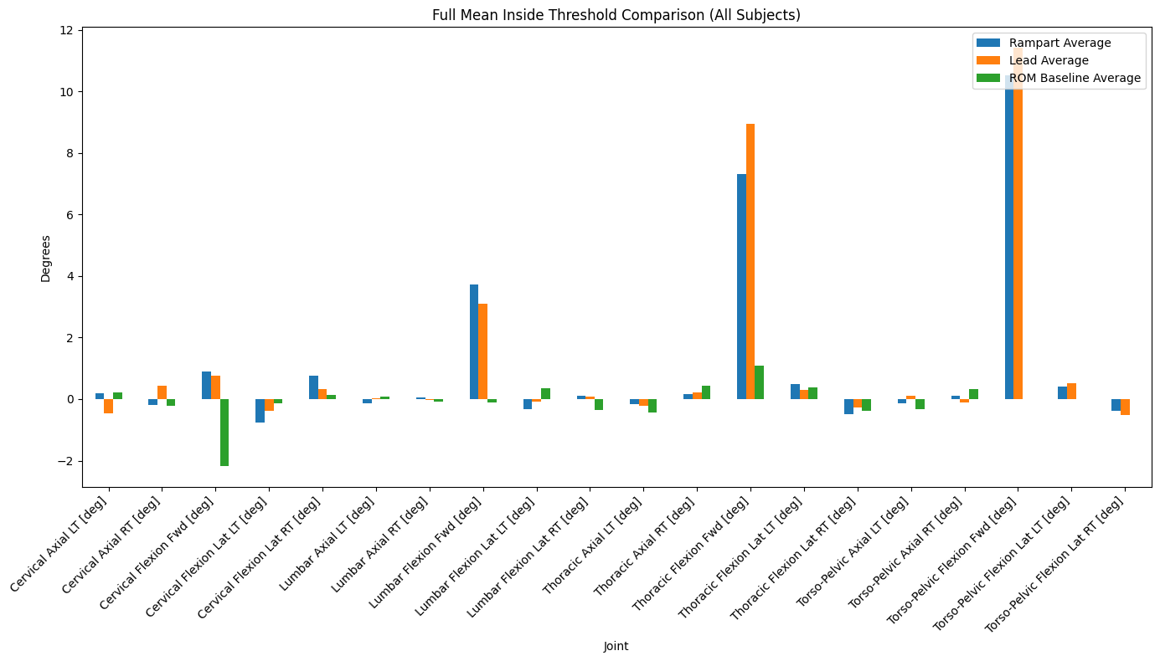
  + Here are the averages from all the values found at these instances.
* 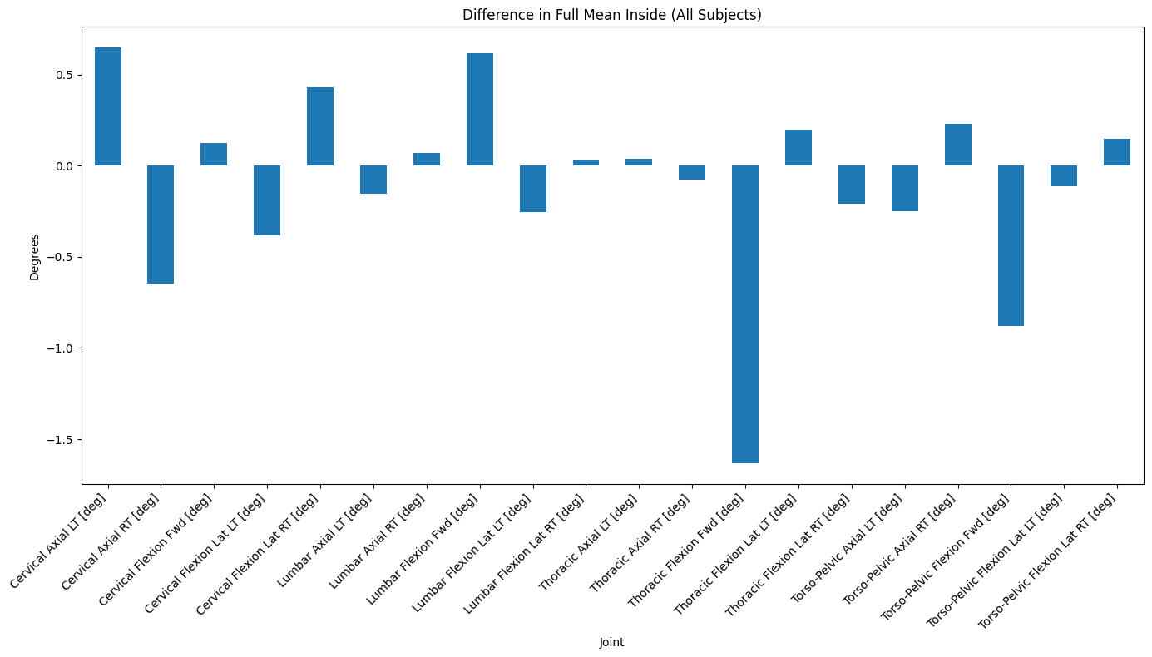
  + Here is the difference between rampart - lead for this instance.
* 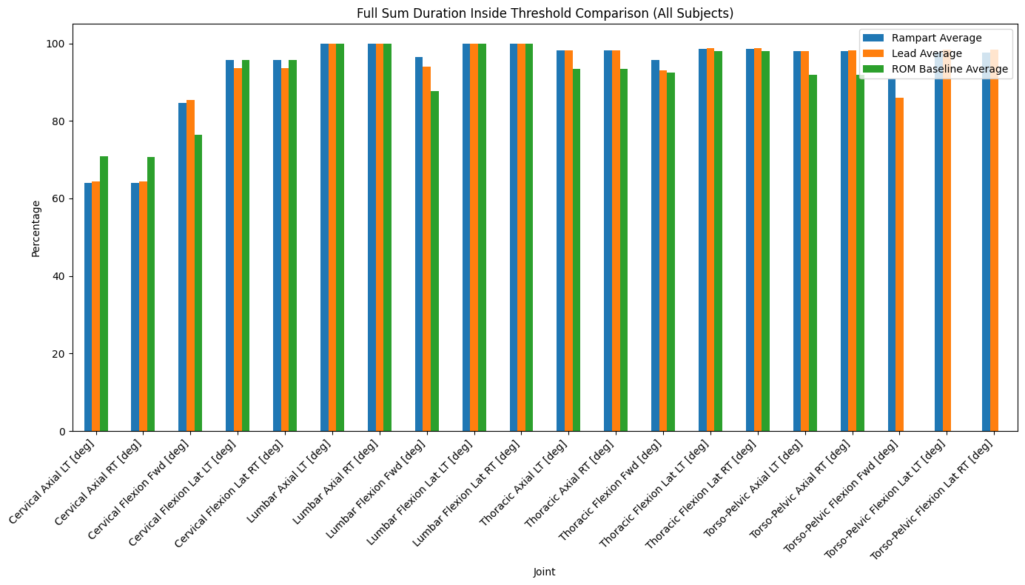
  + Here above is the sum of duration percentages relating to each joint while within the degree threshold.
* 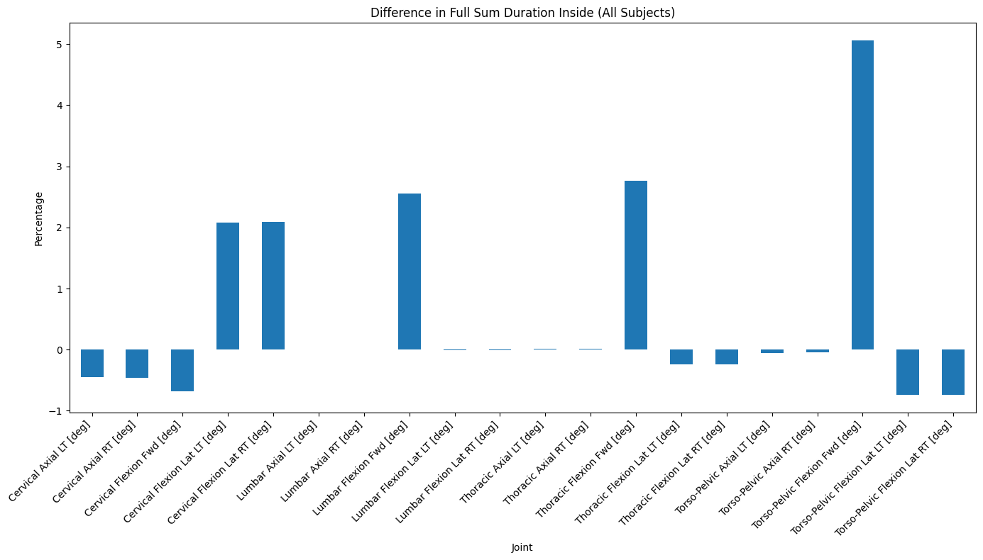
  + Here is the difference between rampart - lead for this instance.

# Mean Above Threshold Averages

* 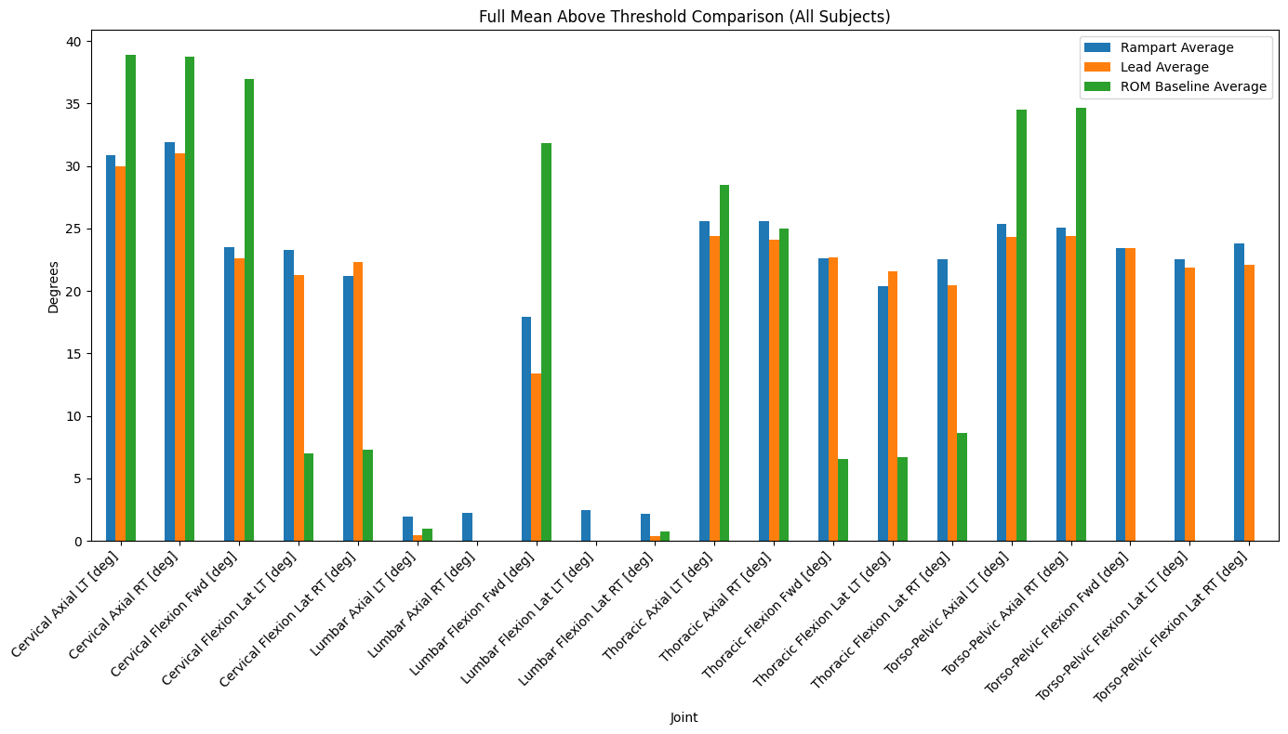
  + Here are the averages for this instance.
* 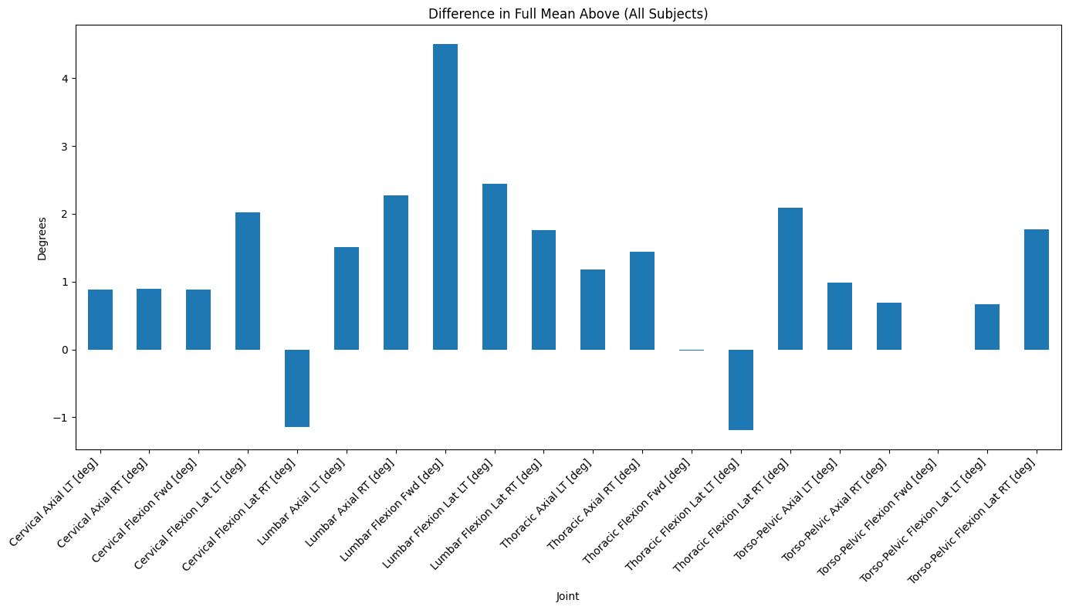
  + Here are the differences between the rampart - lead for these instances.
* 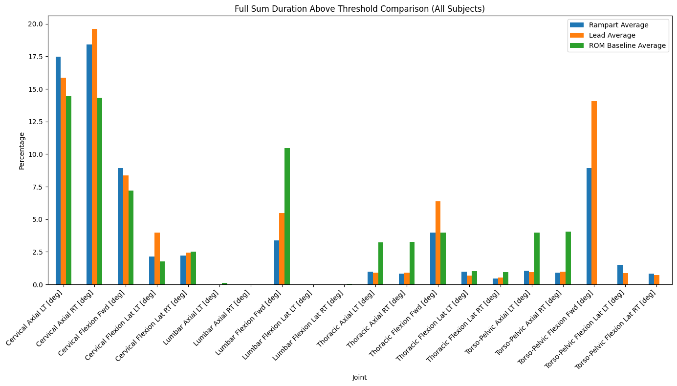
  + Here is the sum of duration percentages above the degree threshold.
* 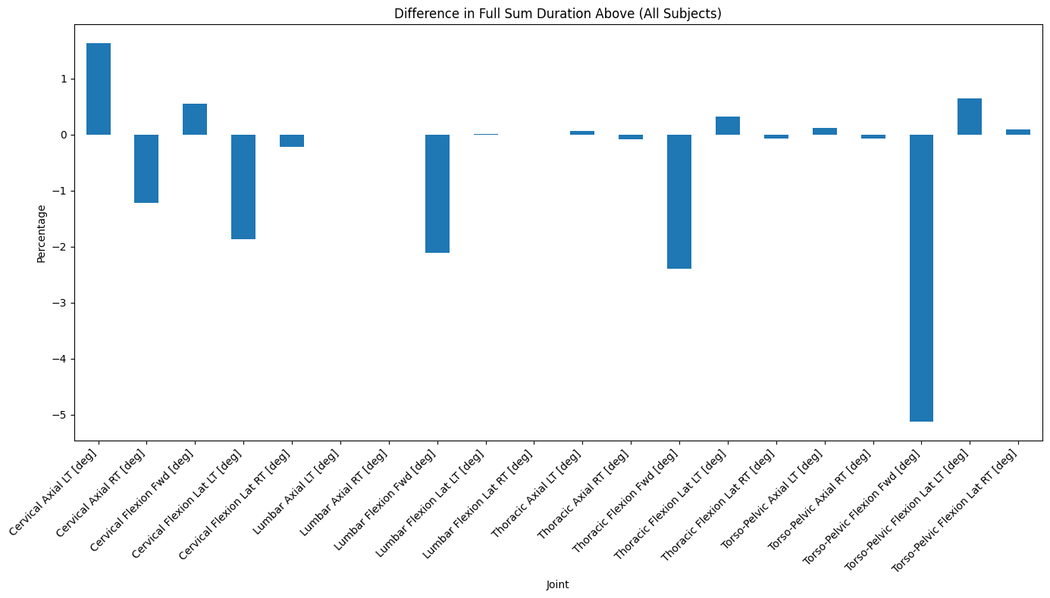
  + Here is the difference between rampart - lead for this instance.